Diameter standard deviation based triggers

Owen Lu

Electroimpact Inc.

owenl@electroimpact.com

*Abstract*—On the 4017 Top heads it was found that interference between the diameter sensors was present. Currently, it has been shown that using shielded cable can reduce the interference between the sensors. The exact mechanism by which the interference occurs is still unknown at the time of writing. This paper describes a standard deviation based trigger which, when tuned, can be used to identify regions where the readings have interference.

# Introduction

It has been found that from the previous study, ultrasonic sensors do exhibit noise and sometimes spiking in readings when using unshielded cable. Figure 1 taken from “Ultrasonic sensor noise filtering” is shown. Clearly, the shielded cable reduces large spikes as well as general random noise. As a result, shielding was suggested as the first trial solution to the problem. Ben Wiggins has investigated the issue and has shown that ungrounded shielding has definitely reduced the interference between the sensors, although large spikes are still present. Thus, this trigger was designed to identify potential problem areas where additional filtering or rejection can be run in case shielding could not completely remedy the issue.

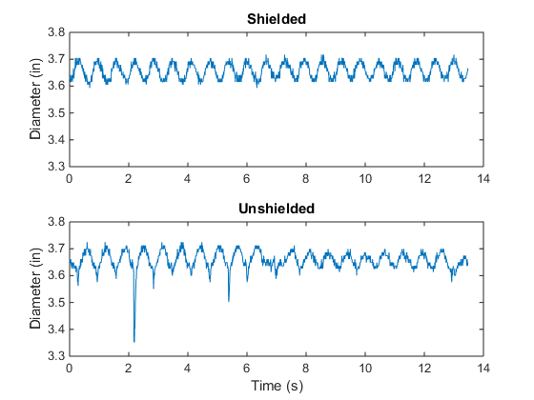

Figure 1 - Shielded vs. Unshielded cable diameter readings

# Wiring

An important finding was that PIN 4, the synchronization pin for the BUS 004J, should be grounded to reduce large spiking. This has not been done on the 4017 heads and has been left floating which is why I believe there are still large spikes.

Figure 2 is taken directly from the datasheet showing that on a high input voltage the sensor is deactivated. This should be grounded since we want the sensors on at all times.

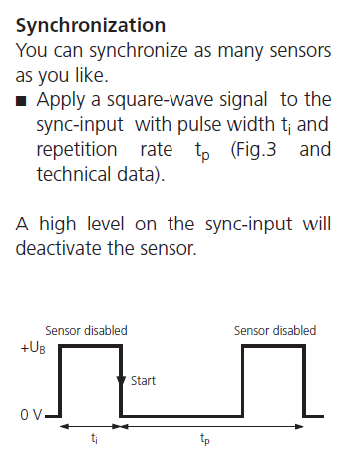

Figure - Synchronization pin should be grounded

# Standard Deviation Assumption

Assuming that ambient noise is present the standard deviation is some small number during normal operation without interference. As shown in Figure 1 there is a sinusoidal wave that is superimposed on the diameter reading since there is a wobble. Notably, on the test setup, the alignment was poor relative to the real machine. However, imperfections in the carbon spool itself will cause the reading to have a larger standard deviation than the deviation due to standard noise.

Thus, there are three elements to the standard deviation.

\

|  |  |  |
| --- | --- | --- |
|  |  | () |

Where

is the effective standard deviation

$σ_{c}$ is standard deviation due to variations in carbon spool diameter

$σ_{m}$ is the standard deviation caused by misalignment

$σ_{s}$ is the ambient sensor noise that is always present

During operation all three elements of standard deviation are present. However, while the spool does not rotate, then only the sensor noise should be present. The main argument is that the effective standard deviation should be approximately constant during operation, and that changes in this standard deviation are a result of sensor failure. Although standard deviation is generally used to talk about random variation, these standard deviations are certainly not random as they follow a cycle with a period dependent on the rotational speed of the spool.

Notably, changing the spool will change the standard deviation calculated from a moving standard deviation window. Currently, there is a method to resolve this issue implemented by Dustin Schmidt using dual moving average buffers. At this time, it is assumed that similar methods can be used in parallel with standard deviation trigger.

# Algorithm

Since the standard deviation should be constant throughout the payout, all we need to do is sample it sufficiently to get a good estimation. At this point, the window used for the standard deviation estimation is 100 samples. This was done through empirical testing with no theoretical basis.

There are three basic steps to the procedure:

1. Calculate the standard deviation in a window
2. Calculate the derivative of the standard deviation
3. Take the absolute value of the derivative signal
4. Smooth the signal further
   1. Suggest a unity gain first order filter for ease of calculation and computation time
5. Set a threshold of the change in standard deviation used to trigger additional filtering or rejection of readings

Notably, the derivative does not have to be with respect to time. It can be done as a difference calculation or equivalently thought of as a numerical derivative with unity step size.

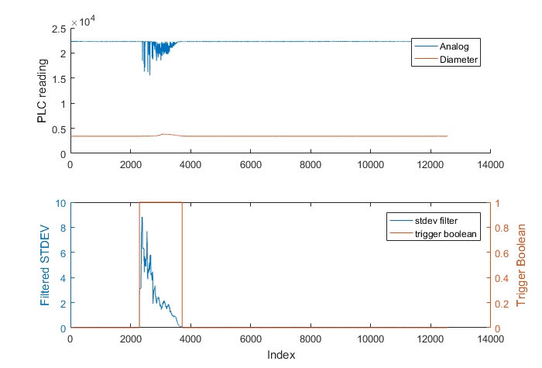

Figure – Standard deviation trigger used to find signal interference

# Conclusion

The necessity of such a filter has yet to be proven especially after the proper hardware changes have been made. Currently, there are plans to move to shielded and grounded cables which will likely reduce or completely eliminate the issue. Currently, shielded cable has already eliminated the noisy looking interference waveform in the 30-minute window testing. In the case where only large spikes are present, the current filter will likely prevent these issues from adversely affecting performance in a meaningful way. If need be, a good way to completely eliminate these spikes is to use a median filter combined with a moving average, which has been shown to work in a previous paper.